**EVENT MANAGEMENT SYSTEM**

**(EVENTRIX)**

1. **MAIN PAGE**

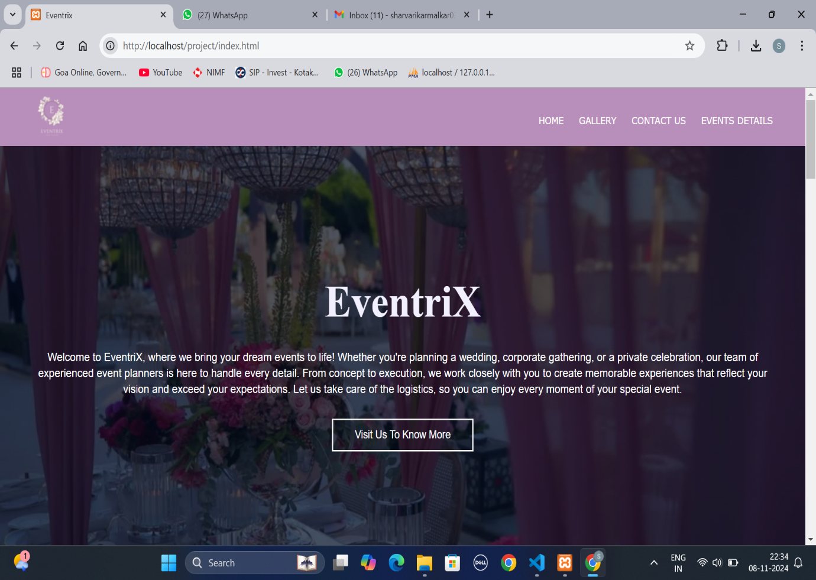

1. **CONTACT US PAGE TO GET EVENT BOOKING DETAILS FROM USER**

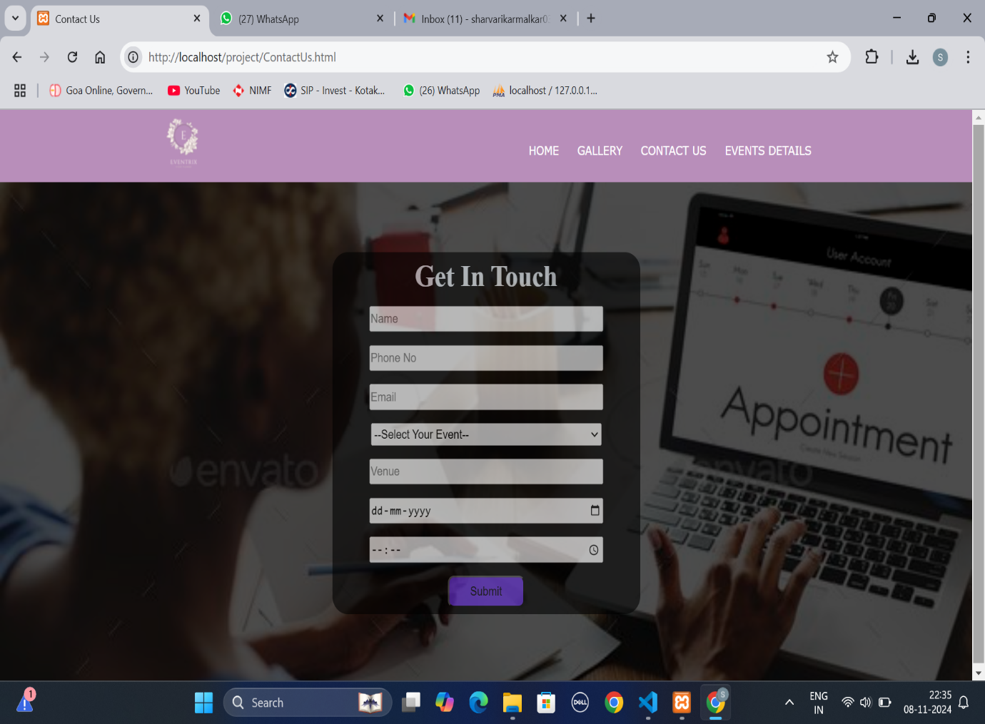

1. **CONTACT US PAGE WITH USER INFORMATION (INSERT INTO TABLE)**

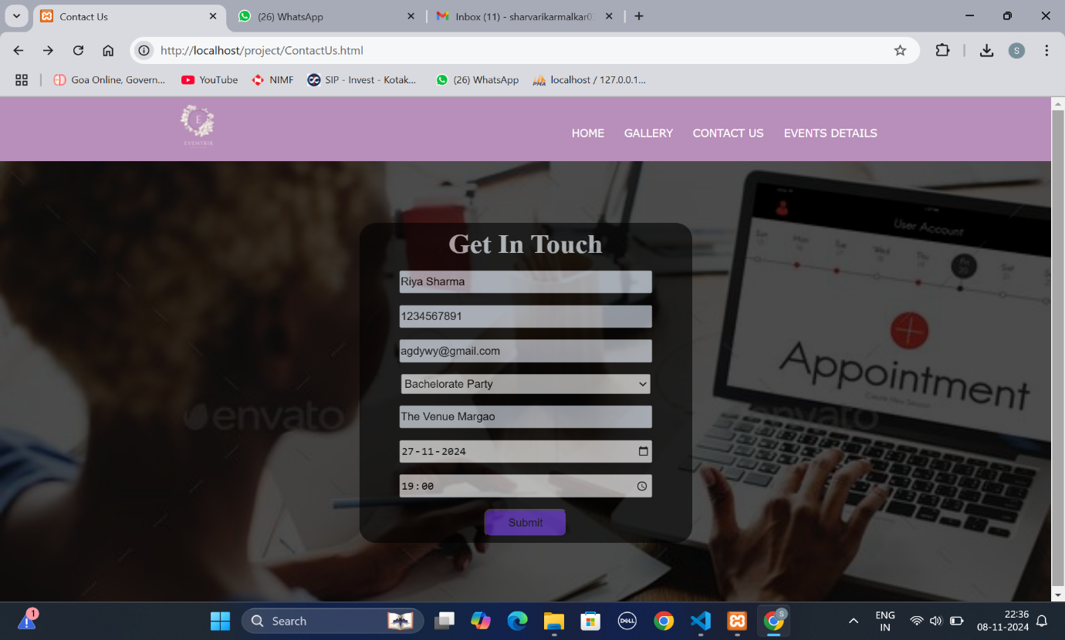

1. **MESSAGE DISPLAYED AFTER SUCCESSFUL SUBMISSION OF USER DETAILS**

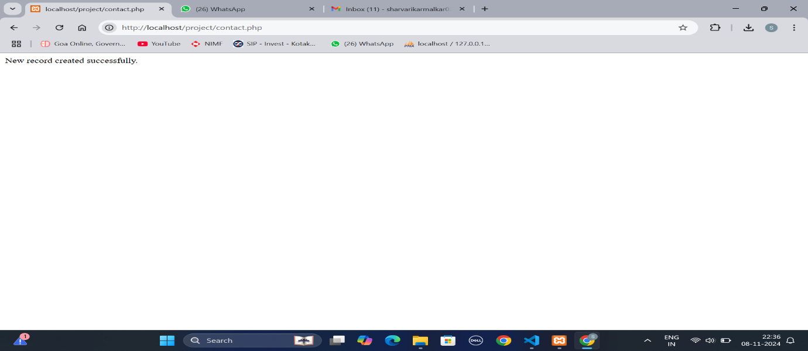

1. **DETAILS OF USER STORED IN THE TABLE**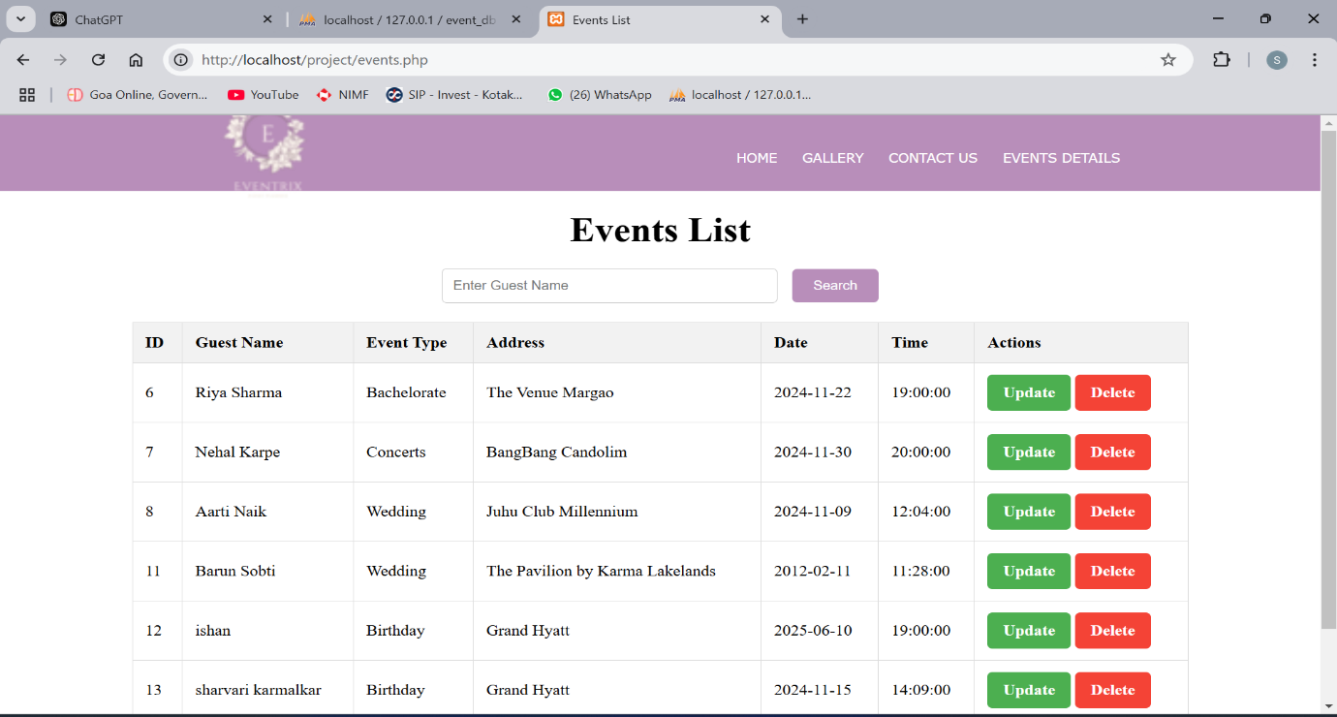
2. **UPDATE ATTRIBUTES OF THE EVENT TABLE**

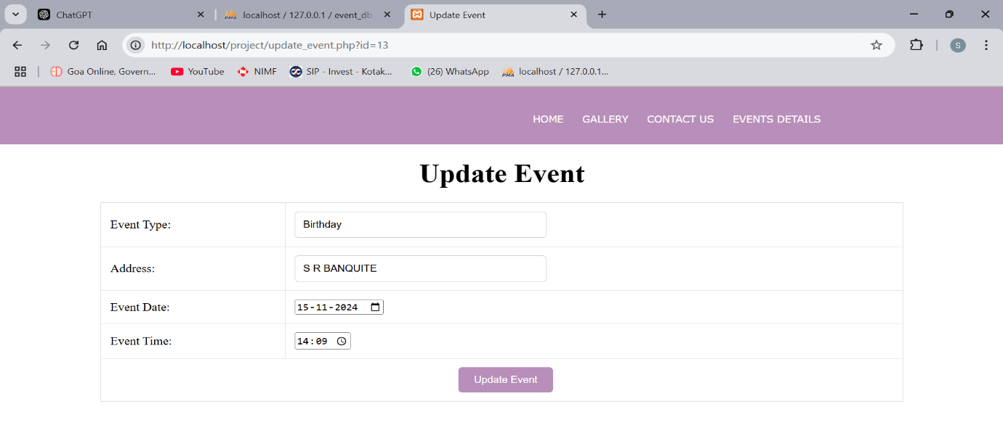

1. **DELETE ATTRIBUTES FROM THE TABLE**

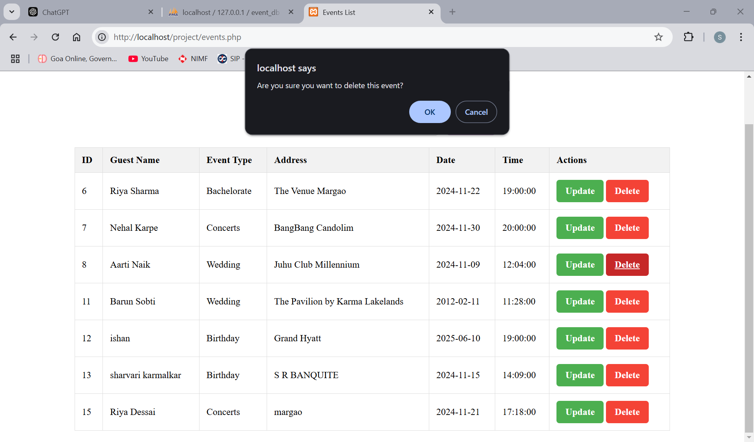

1. **SELECT OPERATION**

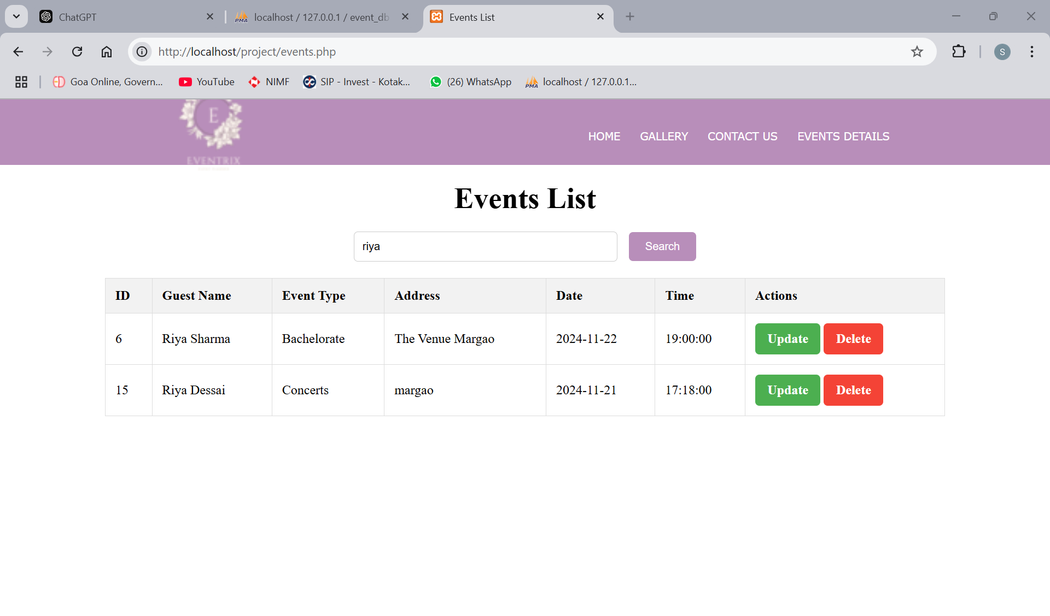

**SQL QUERIES**

1. **INSERT OPERATION**

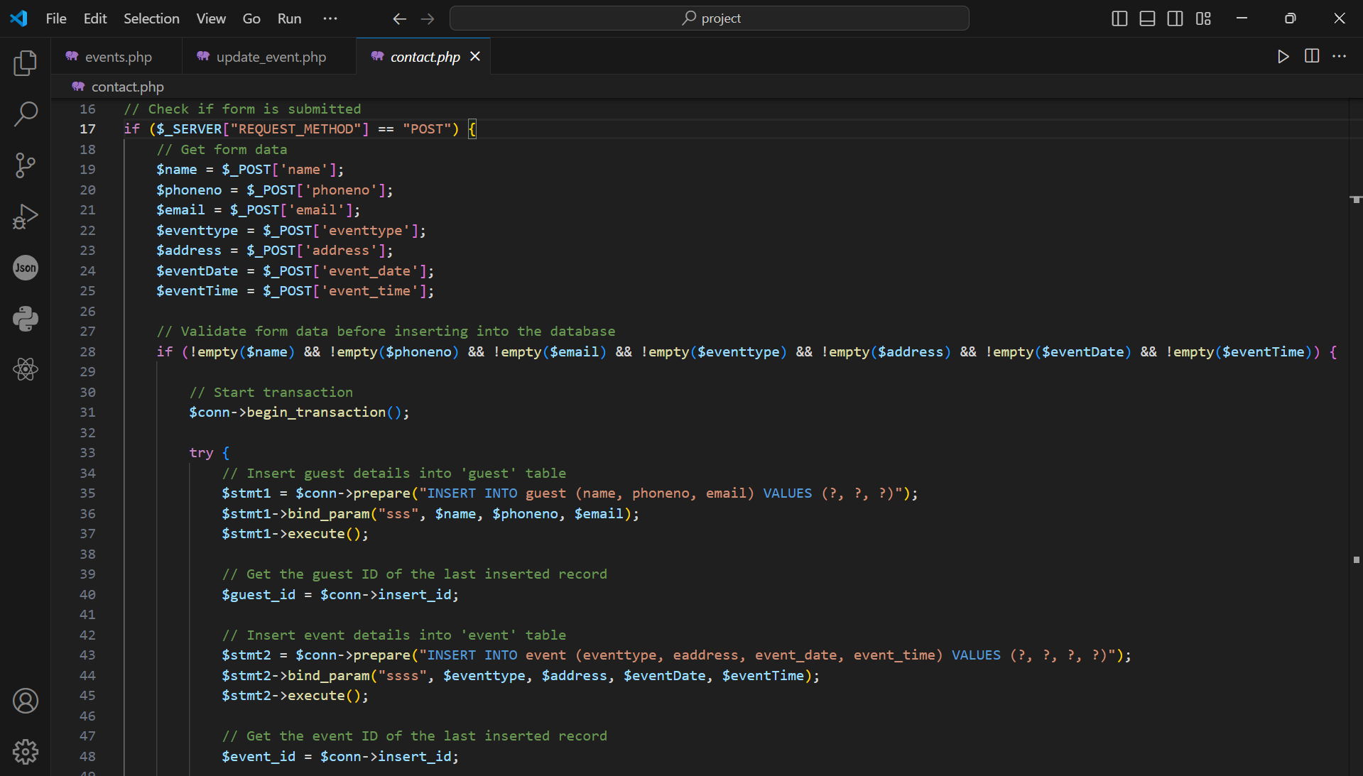

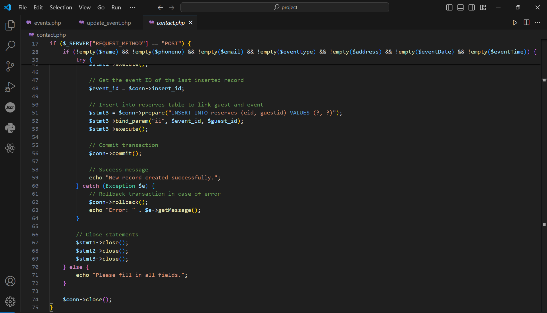

1. **SELECT OPERATION**

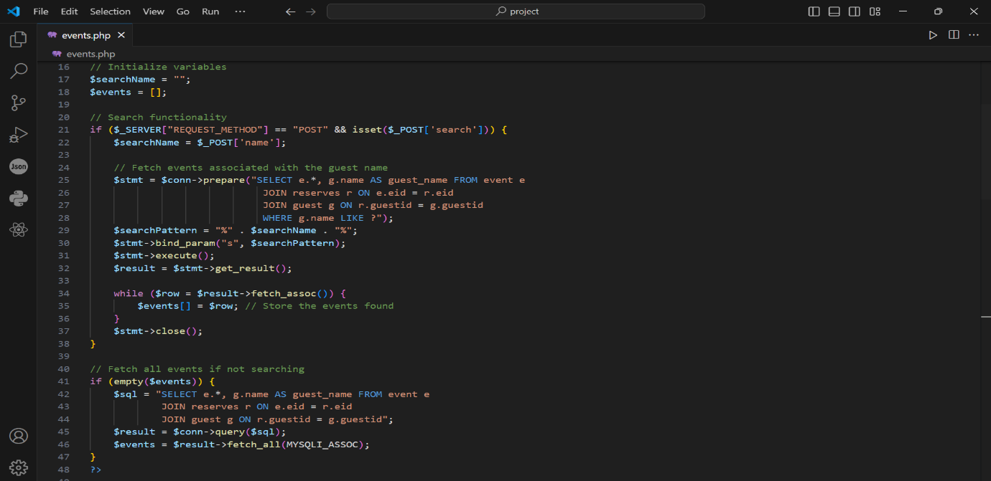

1. **UPDATE OPERATION**

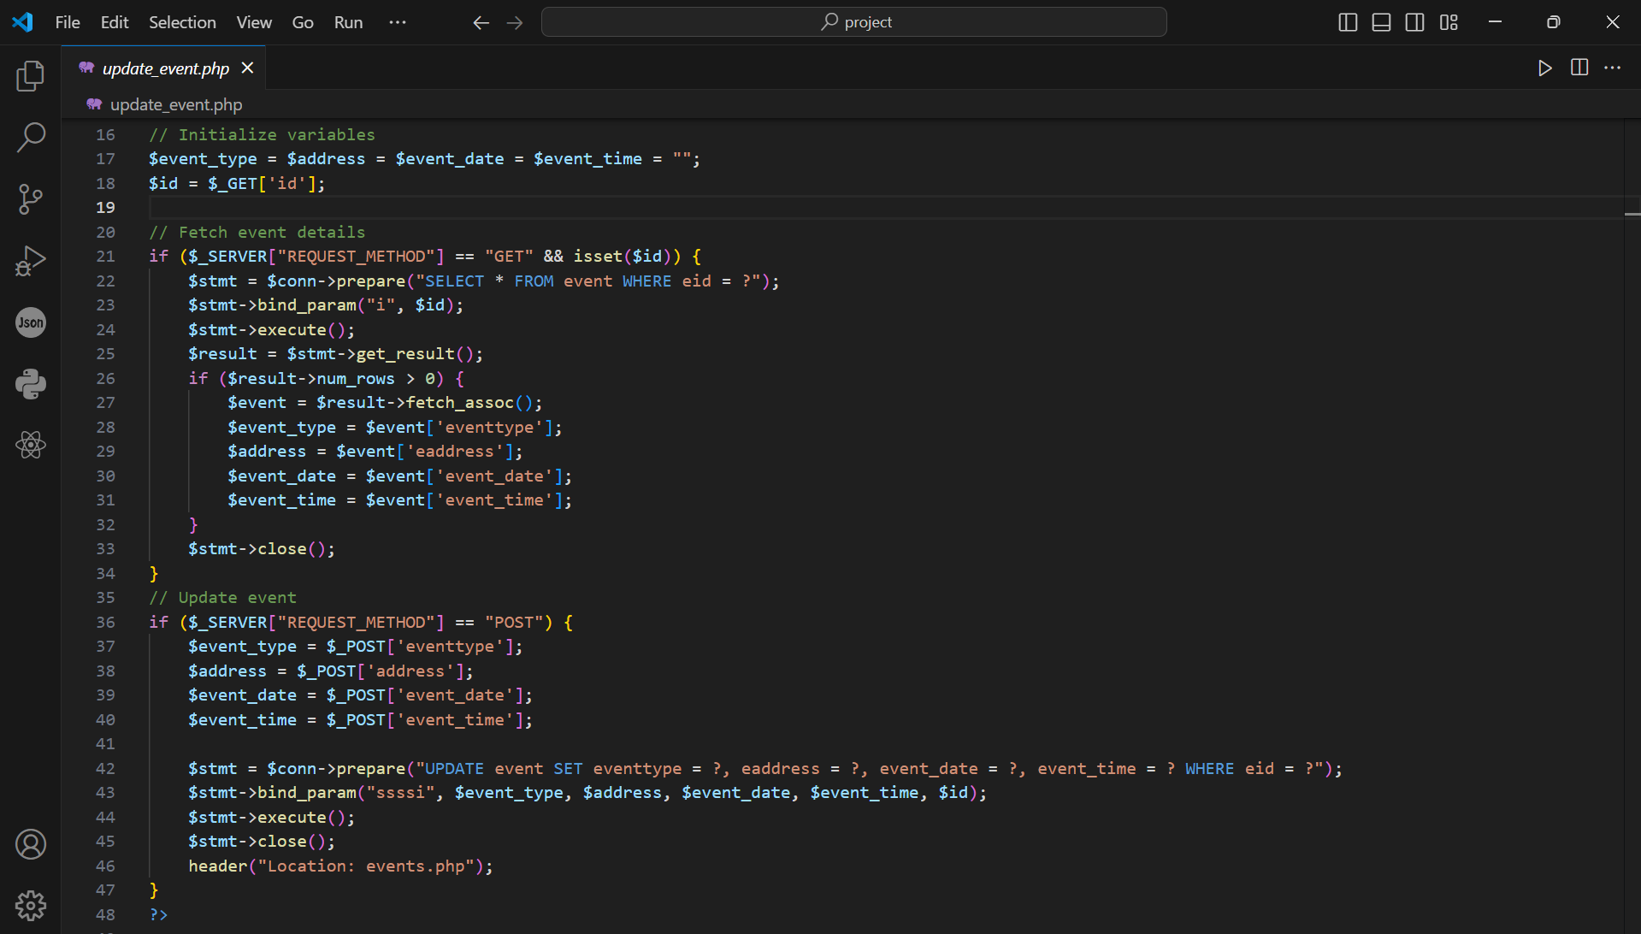

1. **DELETE OPERATION**

